# Assignment -3

Build CNN Model for Classification Of Flowers

|  |  |
| --- | --- |
| Assignment Date | 30 September 2022 |
| Student Name | Ishani S |
| Student Roll Number | 211419104107 |
| Maximum Marks | 2 Marks |

# Question-1:

Download the dataset

# Question-2:

Image Augmentation

# Solution

from tensorflow.keras.preprocessing.image import ImageDataGenerator train_datagen=ImageDataGenerator(rescale=1./255,zoom_range=0.2,horizontal_flip=True,vertical_flip=Tr ue)

test_datagen=ImageDataGenerator(rescale=1./255)

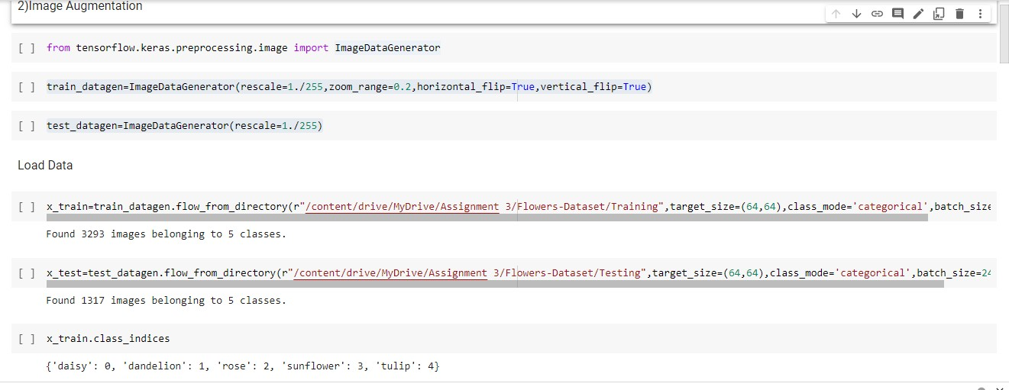

# Question-3:

Create model

# Solution

from tensorflow.keras.models import Sequential

from tensorflow.keras.layers import Dense,Convolution2D,MaxPooling2D,Flatten model=Sequential()

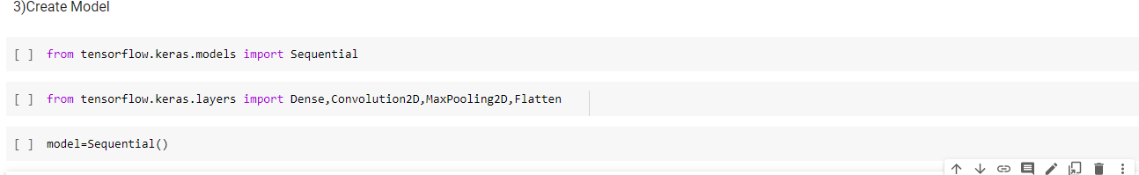

# Question-4:

Add Layers (Convolution,MaxPooling,Flatten,Dense-(Hidden Layers),Output)

# Solution a)Convolution Layer

model.add(Convolution2D(32,(3,3),kernel_initializer="random_uniform",activation="relu",strides=(1

,1),input_shape=(64,64,3)))

# MaxPooling Layer

model.add(MaxPooling2D(pool_size=(2,2)))

# Flatten Layer

model.add(Flatten())

1. **Dense(Hidden layer)** model.add(Dense(300,activation="relu")) model.add(Dense(300,activation="relu"))

# Output layer

model.add(Dense(5,activation="softmax"))

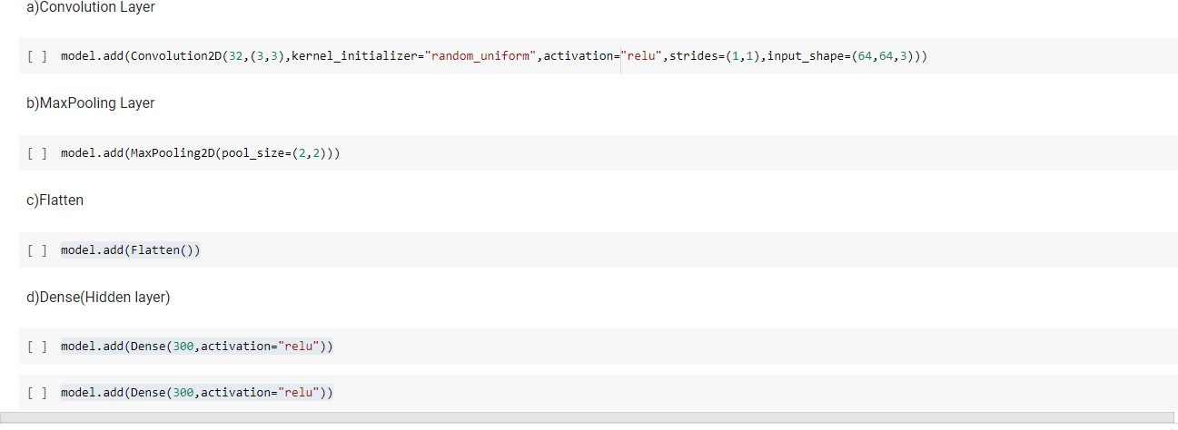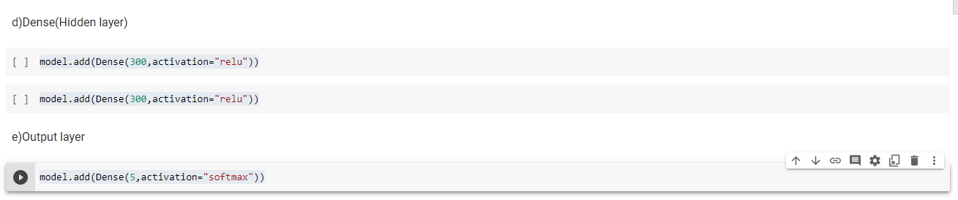

# Question-5:

Compile The Model

# Solution

model.compile(loss="categorical_crossentropy",metrics=['accuracy'],optimizer='adam')



# Question-6:

Fit The Model

**Solution** model.fit(x_train,epochs=5,steps_per_epoch=len(x_train),validation_data=x_test,validation_steps=l en(x_test))

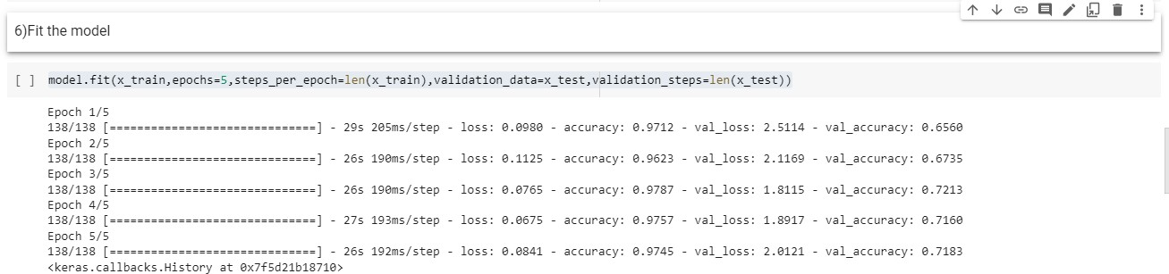

# Question-7:

Save The Model

# Solution

model.save("Flowers.h5")



# Question-8:

Test The Model

# Solution

import numpy as np

from tensorflow.keras.models import load_model from tensorflow.keras.preprocessing import image model=load_model("Flowers.h5")

img=image.load_img(r"/content/drive/MyDrive/Assignment 3/Flowers- Dataset/Testing/daisy/14333681205_a07c9f1752_m.jpg",target_size=(64,64)) x=image.img_to_array(img)

x=np.expand_dims(x,axis=0) pred=model.predict(x)

pred index=['daisy','dandelion','rose','sunflower','tulip'] index[np.argmax(pred)]

